FINGER RUN DESIGN AND ALGORITHM

The image below shows my first sketch for the Finger Run game. At first, I called it Drop Run. However, I decided to change it to Finger as it is a more descriptive name than Drop Run.

**Sketches/Designs**

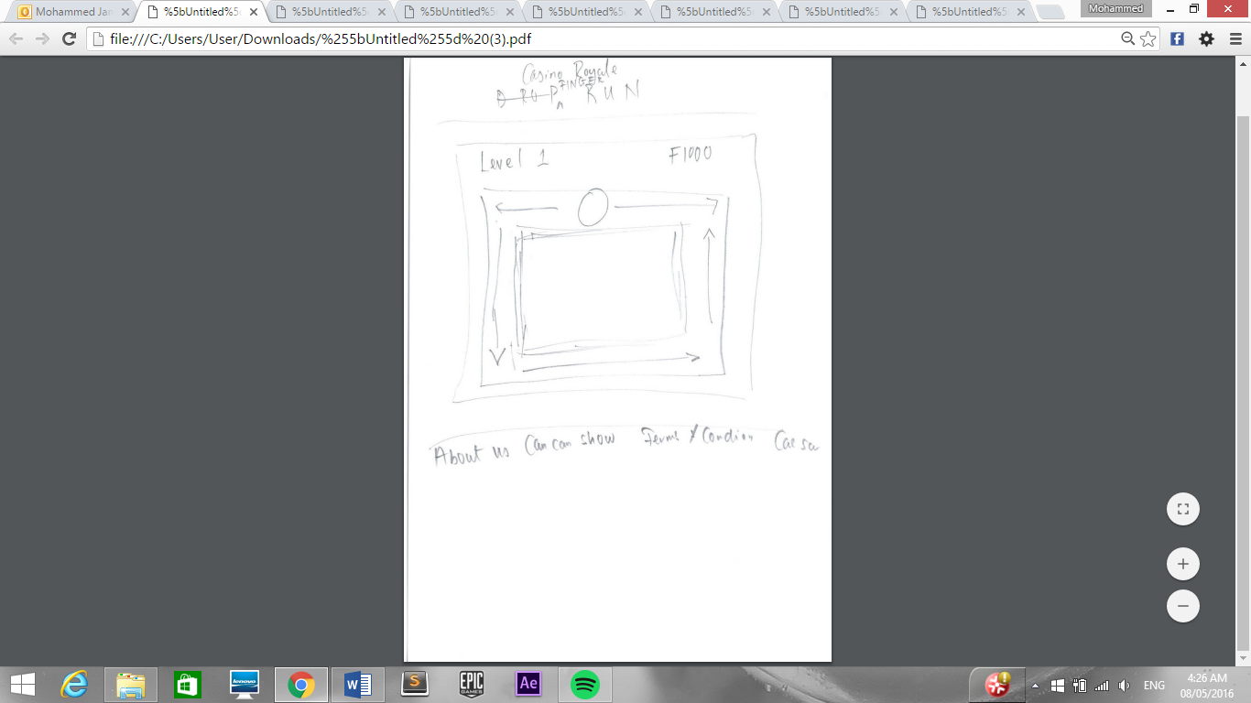

After changing the games name, I decided to redesign it and add some new features to make it more interactive and interesting. As you can see, the new design has a ‘start’ button and a timer which was not included in the first design of the page.

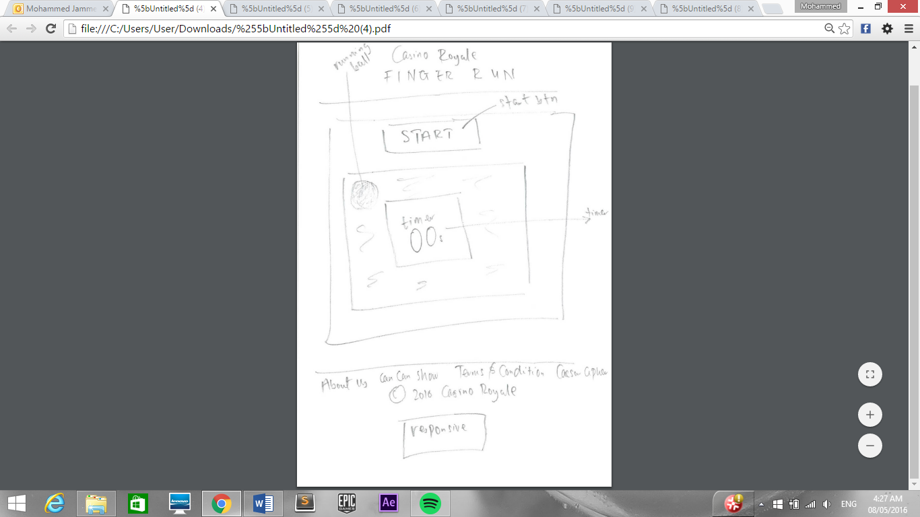

**Pseudo Code (1)**

After sketching the game, I started writing the pseudo code. However, this was not very successful as I have never programmed a game or application that involves the use of keypresses so I had to do more research and figure out how to properly include keypresses in the game.

Furthermore, when I was writing this pseudo code, I had a different idea for the game and that is the reason why my actual pseudo code is different to this one below.

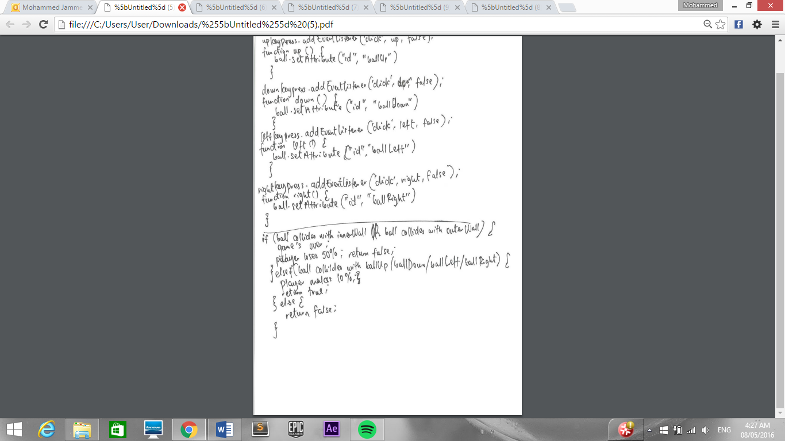

**Algorithm**

After having little success with my pseudo code, I decided to write an algorithm instead. This was quite successful and I have managed to add my new idea to it. On the other hand, I was not confident if I would be able to implement it.

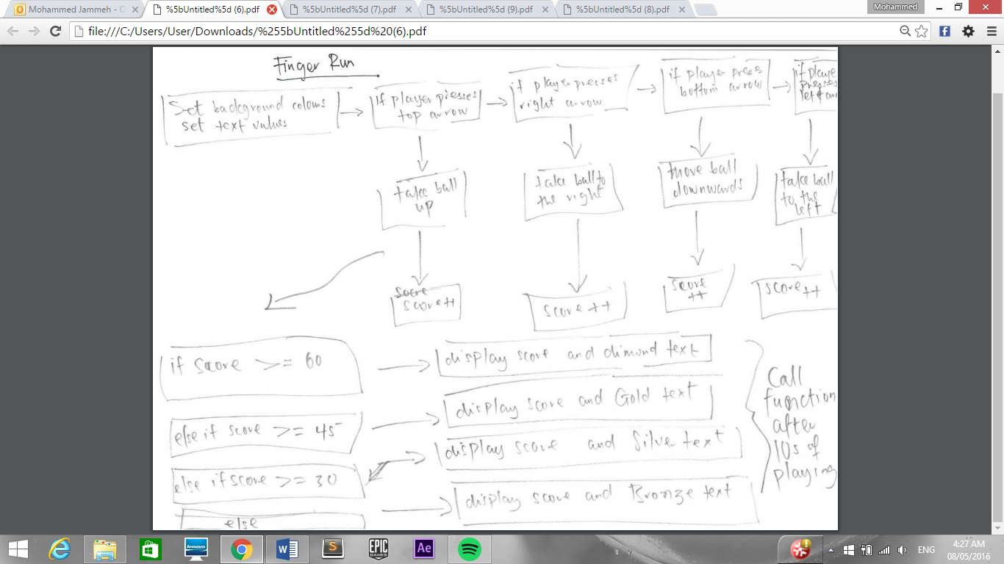

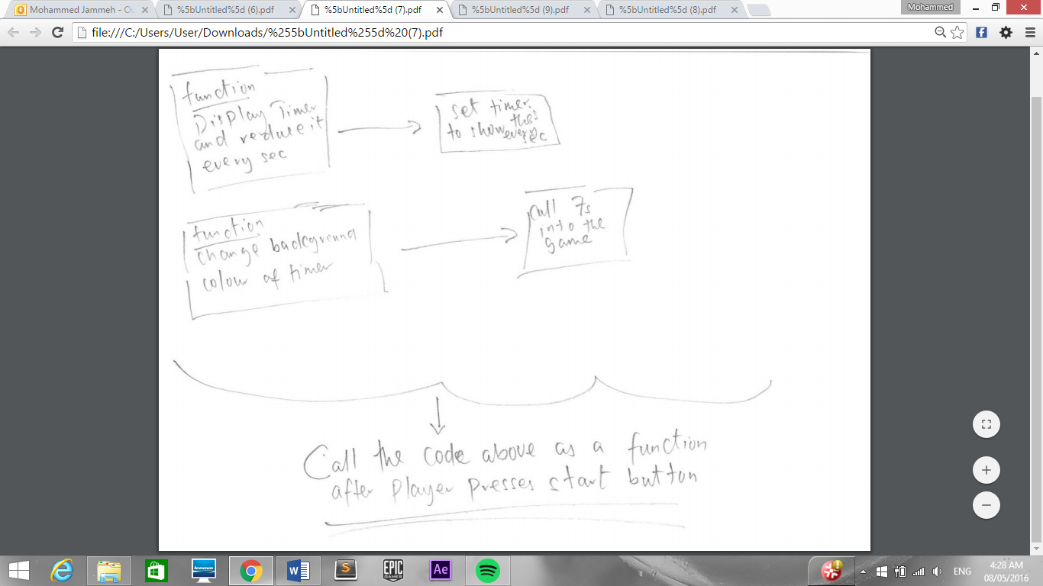

**Pseudo Code (2)**

Before writing the code for the game, I started writing the pseudo code again. However, I struggled to write down my idea as I was not exactly sure how keypresses work so I kept on trying and researching. In the end, I ended up writing the pseudo code and the code for the game together.

Firstly, I researched how keypresses work in JavaScript and applied them to game. I started with trying to make the ball move from top to bottom when a user presses the ‘down’ arrow on the keyboard. It took me about a day to make this work. After this small function was running successfully, I went back to the pseudo code and wrote it again; and I was very confident that the game would work. This time I had an idea how to include keypresses so this made it easier for me to complete the pseudo code and then start developing the game.

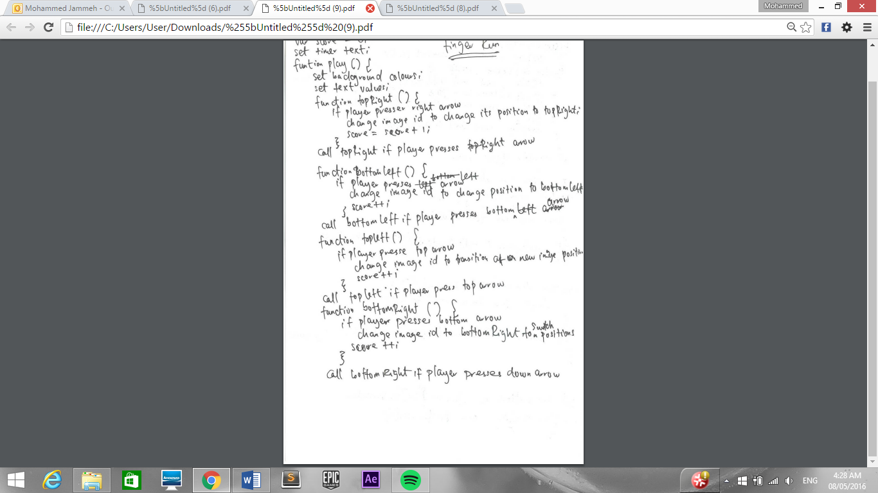

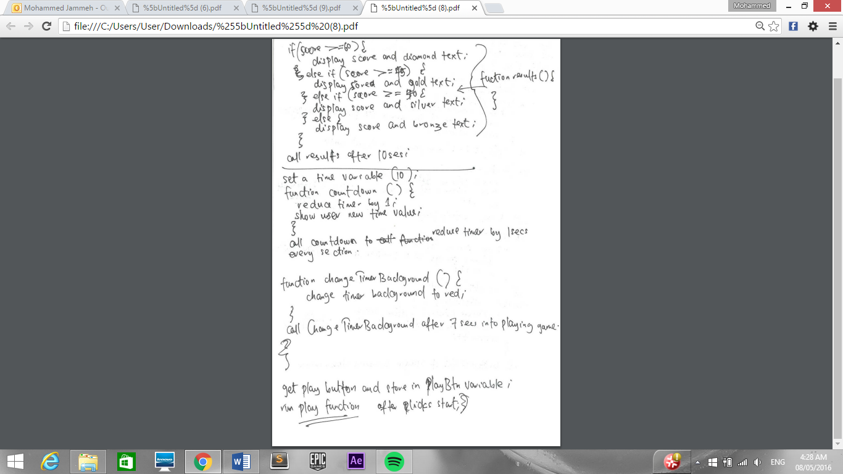

**Screen Design**

The image below is a screen design of the game. It was designed in Adobe Illustrator whilst I was writing the code for Finger Run.

